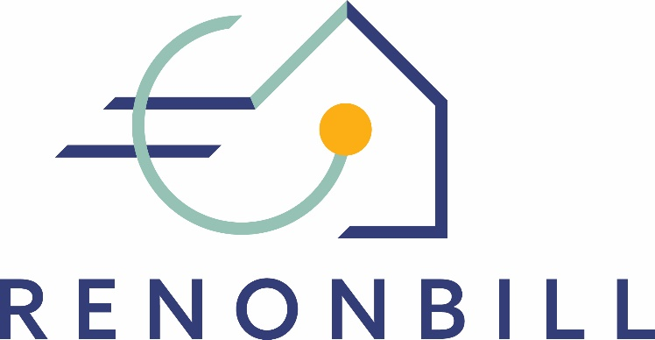

National prototyping workshops
Insights from Spain
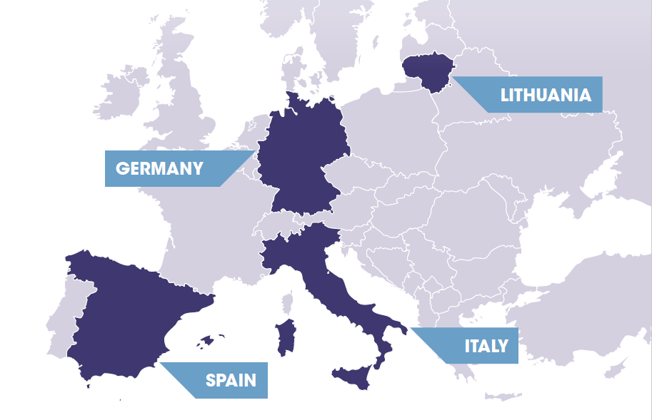
8 April 2020 | Online

This project has received funding from the European Union’s Horizon 2020 research and innovation programme under grant agreement No 847056.

Target market segments for On-bill schemes

Multi-apartment buildings
The workshop participants agreed that multi-apartment buildings with centralised heating and cooling systems represent the most promising segment for OBS in Spain. The focus during the discussion was on owners’ associations in multi-apartment buildings
The main alleged reason was that renovating apartment buildings requires higher investment volumes than those of single houses. Operating at large scale brings advantages: on the one hand, it will be easier to find investors (on the contrary, small and diffuse opportunities are often discarded). On the other hand, these projects can leverage on the standardisation of the process that comes with the scale.
When it comes to disadvantages, participants noted that achieving an agreement to renovate may become a challenging task when there are many homeowners. According to the Spanish Horizontal Property Law, the approval of renovation projects may often require qualifying majorities. In light of the legal complexities related to owners’ associations, the Housing Association of Spain (CONCOVI) promoted the creation of “cooperatives of owners” as a new figure. The main advantage is that cooperatives are regulated by a commercial law that is less strict than the Horizontal Property Law that applies to owner´s associations.
The possibility of signing individual contracts with each homeowner was also brought up, but it was deemed that this would cap the uptake of energy efficiency measures in common areas and limit them to individual properties, which may carry its own complications. Besides that, if the on-bill component implies that all homeowners need to have the same energy provider that could pose a threat to the right of consumers to freely choose their energy provider.
As discussed, an important criteria in choosing the buildings and narrow the target clients is the presence of central heating in the multi apartment building. Such occurrence will mitigate the issue of different energy providers in the same building.
In addition, the renovation proposal must be linked, when appropriate, with improvements in the building accessibility and aesthetics which would be a decisive factor for potential customers.

Single-family houses
Single-family houses are another segment that workshop participants in Spain discussed. The main advantage of this segment is that the acceptance depends only on a single decision maker, the homeowner, in contrast with the multi-apartment buildings.
However, projects will be smaller and therefore, less attractive for financiers. Single-house owners may have easier access to loans at commercial rates, because banks are less reluctant to credit, at least compared to household communities. However, those are just regular small loans which will not have the impact incentivising deep and massive renovation as promoted by the RenOnBill project. However, on-bill renovations in single-family houses located in complexes can also give visibility to the advantages of the scheme and encourage their take up by other homeowners.
In terms of the scale of the projects, another issue that was brought up is that in single-family houses, the renovations tend to be focused on aesthetic aspects rather than improvements in efficiency. This can also be considered an opportunity to make the renovation offer more attractive to final clients.
The table below gives an overview of market segment discussions during the prototyping workshop in Spain.
 | Owners’ associations in multi-apartment buildings | Single-family house owners
Advantages | - Access to larger projects with higher investment volumes | - No need to reach an agreement among several owners
Disadvantages | - Difficulties in achieving the needed majorities among apartment owners to undertake renovation projects (as required by the Horizontal Property Law)  - Imposing a utility could be a restriction on the free choice of energy supplier | - Mainly small scale projects that can be financed by consumer credits
Other aspects | - Centrally heated buildings may the most suitable starting point for an OBS  - Energy renovations will be more successful if they are accompanies by other benefits such as improvements in accessibility (e.g. barrier-free access) or aesthetics. | - Aesthetics (e.g. exterior appearance of a house) play an important role in (energy) renovations

ON-BILL PROTOTYPE
The workshop participants chose to develop a prototype valid mainly for large scale projects, i.e. multi-family buildings.
In this model financial resources are provided from third parties. It would therefore be an on-bill repayment scheme. According to some participants, rather than banks, specialised investment funds are better prepared to understand this kind of projects.
The on-bill model would function as follows: In a first stage, the utility receives the energy renovation requests from its clients and caters them to a master servicer. In this model, the master servicer becomes a relevant piece. It can help in seeking for funds and contributes to provide some degree of flexibility to the model covering the gaps that classical financial agents cannot fill:
- Acting as a standardising agent
- Analysing the associated risks of the project
- Aggregating projects from different utilities to gain volume
In a second phase, the master servicer offers these investment opportunities to financial agents that in turn can resell the credit rights in the capital markets.
To align the scheme to the evolution of the energy sector, the representative from the construction sector noted that the model should be also compatible with the recently emerging concept of prosumers/energy communities.
During the workshop, the participants (guided by the moderator) developed the figure below, visualising the envisaged on-bill scheme for the Spanish market.
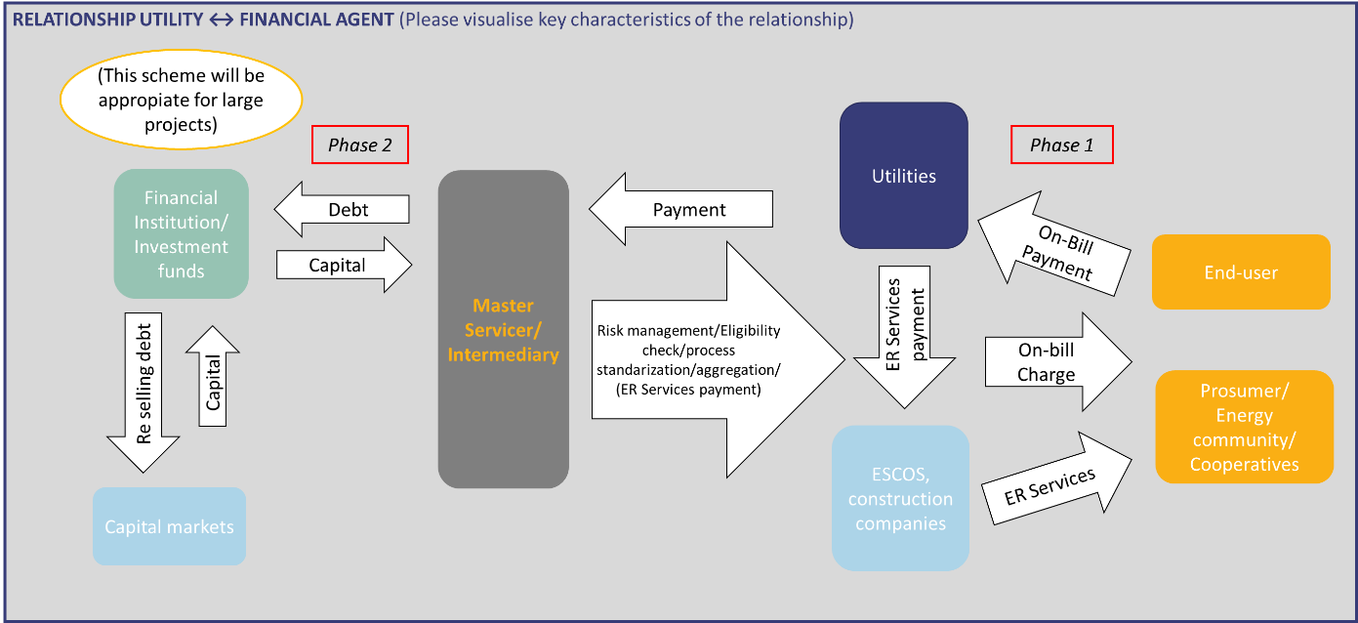
One of the issues raised during the workshop was that profitability may suffer due to the presence of several intermediaries (assuming each intermediate agent will take a cut). However, one of the representatives from the financial sector argued that this effect would be compensated by accessing to financial resources in better terms, which can be expected from the work of those intermediaries.
Participants also brought up the difficulties or maybe even the impossibility of adding differentiated terms to the electricity bill, as well as how the possibility of disconnecting users would be handled in case of default in one of the items (electricity bill or renovation bill). These are regulatory issues that remain open at this point and are perceived as a barrier by participants.
Making a differentiation between energy retailers and distributors was a topic that was also brought up, as in some countries the possibility of the energy distributor being “in charge” of the scheme has become a reality. This highlighted two possibilities:
- Energy distributor: if the distribution service operator (DSO) offers the on-bill scheme, it would have to be regulated by law and enacted by the market authority. This could limit the role of retailers in the on-bill schemes offering.
- Energy retailer: if, on the other hand, it is the utility, the scheme would have to be voluntary, never imposed by law.

CROSS-COUNTRY COMPARISON
During all four national workshops in Spain, Italy, Lithuania, and Germany, participants discussed questions related to the relevant target market segments and to the preferences in terms of source of financing for the on-bill scheme (OBS vs. OBR). By comparison, one can see that “owner-occupied multi-family buildings” represents the most promising segment for on-bill schemes, as it is the only one that is relevant across all four countries. At the same time, participants were aware of the complications that may arise when realising an energy renovation intervention in a setting where owners may hold multiple and different interests.
In Spain and Germany, single-family houses were also considered a potential segment that may serve as a comparatively easy entry point for on-bill renovation measures.
Social housing entities, however, were only mentioned in the Italian context. In any case, the selection of market segments may depend on the stakeholders who participate in the exchange. In Spain, for instance, no social agents participated in the prototyping workshop and therefore, social housing was not discussed as a primary market segment for on-bill schemes.
In terms of the overall preferred on-bill model, all participants agreed that for any large-scale intervention on-bill repayment (where investment capital is provided by a private third party) appears to be more suitable than on-bill financing. Again, this picture may change with more large-scale utilities participating in the exchange.
The table below summarises these findings.
 | Target market segments |  | Preferred on-bill model
 | Owner-occupied single family-houses | Owner-occupied multi-family buildings | Social housing entities | On-bill financing (OBF) | On-bill repayment (OBR)
Lithuania
Italy
Spain
Germany

A prosumer is someone who both produces and consumes energy. Community energy refers to a wide range of collective energy actions that involve citizens' participation in the energy system. The Clean Energy Package recognises certain categories of community energy initiatives as 'energy communities' in European legislation.

