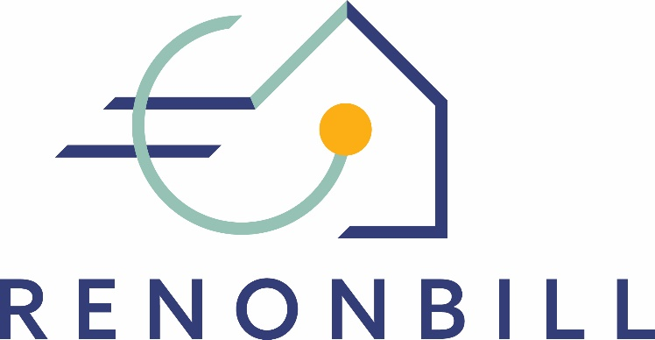

National prototyping workshops
Insights from Germany
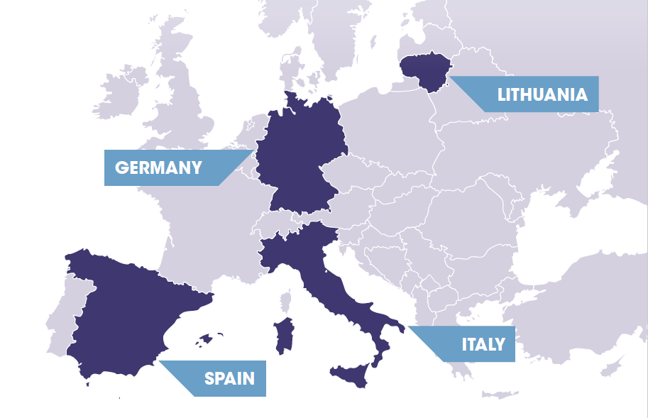
24 April 2020 | Online

This project has received funding from the European Union’s Horizon 2020 research and innovation programme under grant agreement No 847056.

Target market segments for On-bill schemes
During the prototyping workshop in Germany, participants discussed two potential market segments for on-bill schemes, namely (1) owner-occupied single-family houses and (2) owners’ associations in multi-family houses. The table below gives an overview of these discussions.
 | (1) Owner-occupied single-family houses | (2) Owners’ associations in multi-family houses
Advantages | - High potential for energy savings  - High potential for deep renovation  - Potential for “tied-to-meter” schemes due to low fluctuation | - Owners’ associations are perceived as a suitable counterpart for OBS  - Associations often lack own capital for energy renovations and could therefore be interested in external capital provision through the OBS
Disadvantages | - Highly fragmented market  - Single-family house owners may relatively easy access regular bank loans and may therefore be less interested in alternative schemes such as OBS | - Threat of fragmented interests within the owners’ association, especially in case of rented-out properties
Other aspects |  | - While utilities provide services to individual end users, the contractual partner in an OBS would have to be the association (and not the individual owners)

ON-BILL PROTOTYPE
Participants’ discussions during the prototyping workshop in Germany focussed on (i) features of a potential on-bill scheme for the German market; and (ii) the potential business case for each of the stakeholder groups involved. Both discussion streams are summarised below.
On-bill prototype
The proposed model is an on-bill repayment scheme, assuming that large-scale investments require third party capital provision from a financial institution. The utility assumes the role of an energy manager and is responsible for the programme administration. It promotes the on-bill offer as a one-stop-shop towards the final customer. The utility’s knowledge about the final customer (e.g. in terms of bill payment history) is used for the financial institution’s creditworthiness assessment.

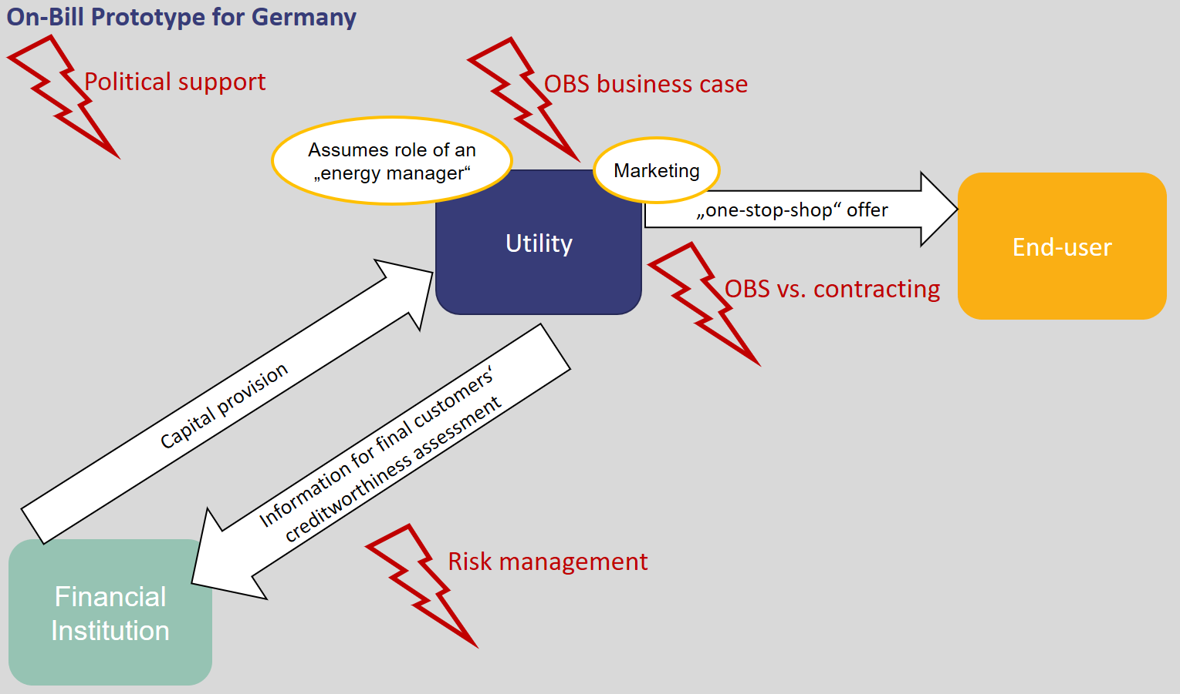

Within the prototype described above, the following issues were particularly highlighted by workshop participants:
- What exactly is the business case for the utility and the financial institution?
- What are the benefits for the final customer?
- To what extent are on-bill schemes different from existing contracting offers?
- What political support is needed?
- How can financial and technical risks be managed?

Business case for energy utilities
During the discussions, it became evident that on-bill schemes can present a potential business case for energy utilities in Germany. While some participants argued that utilities may be reluctant to go beyond the traditional commodity business, many others agreed that utilities see the need to adapt their core business and target more future-oriented business models. This may include the provision of new services, e.g. energy renovation through an on-bill scheme. Against this backdrop, on-bill schemes could present an opportunity for strengthening an energy utility’s business in several ways:
- New revenue streams besides the traditional commodities business
- Access to new clients
- Long-time retention of existing clients beyond the current 1-2 years of current utilities’ contract durations
- Positioning in the market as an energy manager
However, it was also pointed out that especially smaller utilities do often lack sufficient technical staff capacities to manage the full life cycle of an energy renovation intervention. In these cases, cooperation with an ESCO could be an option.
Business case for financial institutions
Workshop participants highlighted two arguments for financial institutions to become involved in an on-bill scheme. First, the cooperation with an energy utility allows entering a highly fragmented market of individual end users – assuming that the utility aggregates potential energy renovation projects. Secondly, the energy utility may provide additional information for the final customer’s creditworthiness assessment (e.g. bill payment history) that otherwise remain inaccessible for a financial institution.
Benefits of on-bill schemes for the final customer
Looking at the demand side of potential on-bill schemes, workshop participants also debated about the attractiveness of on-bill schemes for the final customer. The main argument was that final customers do not need to provide the upfront investment capital for the energy renovation intervention themselves. This is particularly interesting for those customers who may have difficulties in obtaining regular bank loans, including for instance:
- Elderly people who cannot or do not want to apply for a regular bank loan but still seek to increase their property’s value through energy renovation (e.g. before selling or inheriting the property);
- Self-employed people;
- People who have recently borrowed money from a bank (e.g. for the purpose of buying a house) and are hesitant to increase their debt obligations.
One of the bank representatives participating in the workshop also raised that point that private customers often receiver less favourable loan conditions than companies. This also makes financing through a utility bill more attractive than taking up a regular bank loan.
In case final customers do not have difficulties in self-financing an energy renovation and/or in receiving a regular bank loan, the main selling point of an on-bill scheme would be its “one-stop shop” feature, that is the comprehensive service offer provided by the utility.
OBS vs. Contracting
The question in how far on-bill schemes differ from energy performance contracts (EPC) was of interest to many workshop participants. Based on the discussions with the stakeholders but also on an internal exchange within the consortium partners, some insights on this issue have been collected.
In Germany, energy performance contracts have to date mainly been applied in the municipal and commercial building sector, but hardly in the residential sector. Their main feature are the guaranteed energy savings, based on the ESCOs intervention. Measuring and verifying these energy savings is a central element in each EPC. In the residential building sector, however, the guarantee of projected energy savings based on a specific energy renovation intervention is almost impossible to achieve due to the individual customer’s behaviour. Against this backdrop, the potential of on-bill schemes for the residential sector is in the possibility of third-party investment capital provision and indirect repayment through the energy bill without the need for a guarantee on the final customer’s energy consumption. In this sense, on-bill schemes could fill a gap by addressing the residential sector where EPCs are to date hardly common and/or feasible. Also, OBS could target small-scale investments and/or smaller lots of investment projects as opposed to contracting schemes.
Political support
Increasing energy renovation rates in the residential building sector is a political aim – both at national and at EU level – and should therefore be strongly promoted by public entities. Public support schemes for deep renovation measures could be enhanced, for instance for interventions targeting the envelope of multi-family buildings. Workshop participants pointed out that one reason why on-bill schemes are successful in the North American context is the existence of energy efficiency obligations for utilities. These obligations are a major incentive for utilities become involved in on-bill schemes and could also be an impetus for utilities’ increased engagement in energy renovation in Germany.
At European level, the initiative “Smart Finance for Smart Buildings” was mentioned as a potential support mechanism for on-bill schemes.
Risk management
Many stakeholders considered risk management a bottleneck issue since there is no agreement (yet) on how the financial and technical risks of an on-bill scheme could be managed between the parties involved in the scheme. This becomes particular relevant in long-term contractual arrangements for deep renovation interventions.

CROSS-COUNTRY COMPARISON
During all four national workshops in Spain, Italy, Lithuania, and Germany, participants discussed questions related to the relevant target market segments and to the preferences in terms of source of financing for the on-bill scheme (OBS vs. OBR). By comparison, one can see that “owner-occupied multi-family buildings” represents the most promising segment for on-bill schemes, as it is the only one that is relevant across all four countries. At the same time, participants were aware of the complications that may arise when realising an energy renovation intervention in a setting where owners may hold multiple and different interests.
In Spain and Germany, single-family houses were also considered a potential segment that may serve as a comparatively easy entry point for on-bill renovation measures.
Social housing entities, however, were only mentioned in the Italian context. In any case, the selection of market segments may depend on the stakeholders who participate in the exchange. In Spain, for instance, no social agents participated in the prototyping workshop and therefore, social housing was not discussed as a primary market segment for on-bill schemes.
In terms of the overall preferred on-bill model, all participants agreed that for any large-scale intervention on-bill repayment (where investment capital is provided by a private third party) appears to be more suitable than on-bill financing. Again, this picture may change with more large-scale utilities participating in the exchange.
The table below summarises these findings.
 | Target market segments |  | Preferred on-bill model
 | Owner-occupied single family-houses | Owner-occupied multi-family buildings | Social housing entities | On-bill financing (OBF) | On-bill repayment (OBR)
Lithuania
Italy
Spain
Germany

