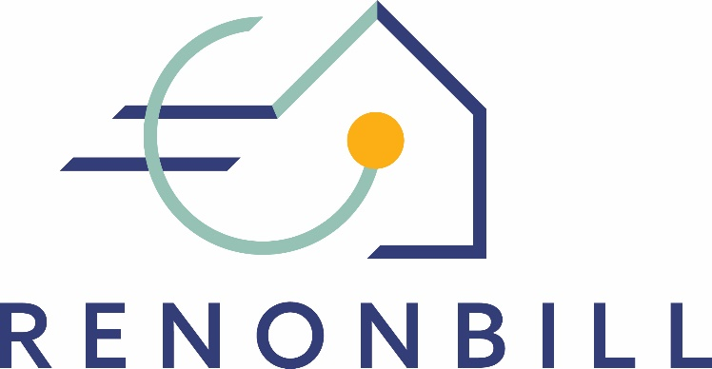

National prototyping workshops
Insights from Italy
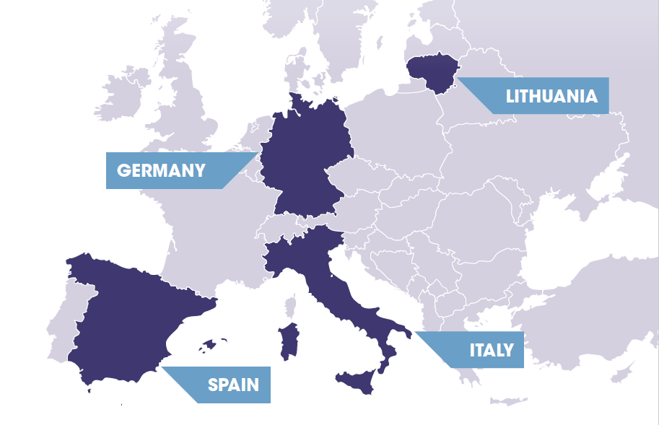
7 April 2020 | Online

This project has received funding from the European Union’s Horizon 2020 research and innovation programme under grant agreement No 847056.

Target market segments for On-bill schemes
During the prototyping workshop in Italy, participants discussed two potential market segments for on-bill schemes, namely owner-occupied multi-family buildings and rented-out social housing buildings. The choice was made considering the scale of the market segments and the different socio-economic status of the end users.
Multifamily buildings represent the vast majority of residential houses In Italy, and dwellings are for their vast majority owner-occupied. Workshop participants saw medium-high income owners as the most likely adopters of energy renovation interventions due to:
- Their higher disposable income;
- The rather high probability of living in inefficient buildings (considering the average low efficiency of buildings In Italy);
- Their likely higher sensitivity to environmental issues; and
- The possibility that these people view energy efficiency interventions as a status symbol.
Social housing has been chosen as a potential market segment for on-bill schemes in order to address the low-income share of households and due to its potential for large-scale deep renovations. In Italy, most social housing entities are publicly owned and handle a huge amount of buildings. Therefore, this segment can be very effective both in delivering deep renovations on a large scale and in promoting a widespread adoption of energy renovation measures throughout the country. The impact of energy renovation interventions in the social housing sector could be felt both from an environmental and economic point of view. Also, energy renovations in the social housing sector can have a significant impact in terms of communication and marketing due to the visual result they can theoretically have on entire blocks/districts, which can trigger word of mouth and an imitation effect. Eventually, the rise of public demand for a measure, as often happens, could lead to widespread adoption of the same measure in the private sector.

ON-BILL PROTOTYPE
During the prototyping phase, the workshop participants were split in two groups, each working on one of the two market segments presented above.
Owner-occupied multifamily buildings
For the segment “owner-occupied multi-family buildings”, workshop participants proposed an on-bill repayment (OBR) scheme with the following characteristics:
A third party (likely a financial institution) provides funding for the scheme. Therefore, the utility does not need to provide any up-front capital itself and does not record any debt in its balance sheet. Instead, the debt is borne by the end user.
The utility’s main role is to act as a programme administrator/ paying agent and as the main point of contact for the end user (one-stop shop). Also, the utility may be responsible of project (pre-)selection with the financial agent having the last word before signing off the investment.
The proposed scheme involves an entity which materially performs the technical job (i.e. the energy renovation measures), typically an energy service company (ESCO) or any other construction company. This entity must be chosen by the utility, and needs to be either an in-house company or a company listed in the utility’s roster of suppliers.
Even if the debt is borne by the end user, the latter does not receive money from the financing third party, but benefits in form of the energy renovation performed on his/her property. The money coming from the financing third party can be channelled, alternatively, as follows:

- The money is deposited on an escrow account managed by the utility, which oversights the programme. Works can be funded on a work progress basis, either in advance of every step or after completion of the step (upon invoice from ESCO/ construction company). In case of payment after completion of the works, the ESCO/ construction company needs to fund the works with its balance sheet. (option A, see below)

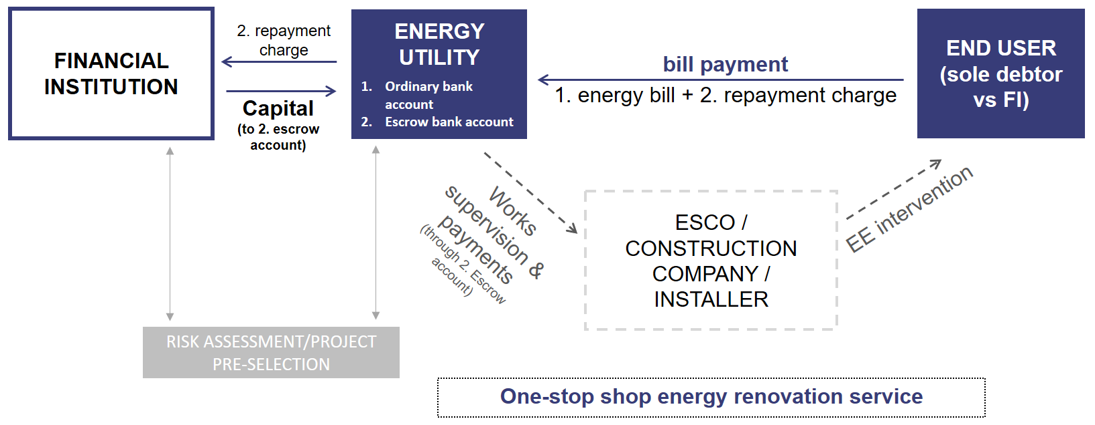
On-bill prototype for the Italian market – option A

- The financing third party retains the money and directly pays the ESCO/ construction company upon invoice. The utility oversights the process. (option B, see below)

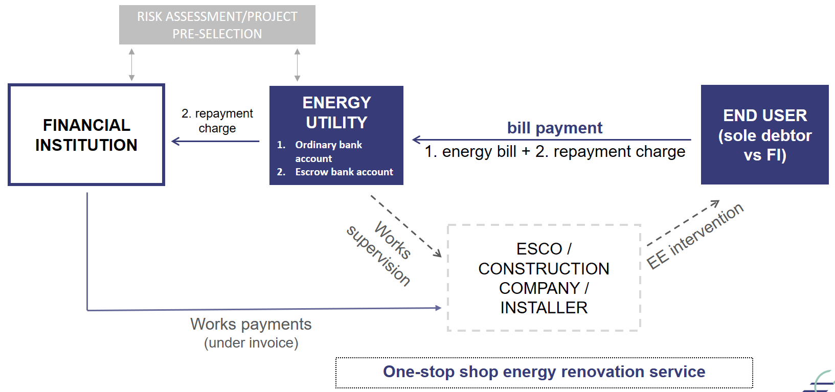
On-bill prototype for the Italian market – option B
In both cases, the intervention is repaid by the end user through the energy bill. The utility acts as a paying agent, and money received flows through an escrow account, segregated from the utility assets. Payments received by the utility are automatically transferred to the financing third party. The exact terms of this set-up may need to be written down in a multilateral agreement involving at least the end user, the utility, and the financing entity.
Social housing entities
Workshop participants identified two segments within the Italian social housing market:
- The social housing entity owns 100% of the property building, and the heating system is centralised;
- The social housing entity owns less than 100% of the property building.
In the first segment (100% ownership), an OBS, in which the repayment of the intervention is made through the centralised heating system's utility bill, does not seem to be the most efficient way of financing an energy renovation. In fact, the bill is paid by the social housing entity, which recovers the sums paid to the utility by claiming repayment from each of the renters, pro quota, based on the consumption recorded on the relevant individual (sub)meter.
Given the average scale of a social housing entity (which is remarkable in Italy), the energy renovation process can be easily directly managed by the entity itself, with no involvement required from the utility with respect to the financing-repayment side of the intervention. The social housing entity can in fact manage the works (and the repayment, e.g. by raising rent fees) either by financing them directly, or by resorting to a financing third party (e.g. a bank and/or public funds), and directly managing such relationship. It is also noteworthy that several social housing entities in Italy own in-house ESCOs.
In the second segment (less than 100% ownership), an on-bill scheme can be a useful mechanism to promote energy renovation. In this case, the OBS would follow the same path as the OBR described for owner-occupied multi-family buildings (see above), especially if the social housing entity’s ownership share is low.
On the other side, workshop participants highlighted that the higher the share of ownership by the social housing entity (which, as mentioned, is typically a public entity in Italy), the easier it is to access financing from a third party (e.g. a bank) for the energy renovation process. It was agreed that public ownership can be an effective risk mitigant for the financing third party.
Having said all that, given the structure of the social housing entities and their operation, a scheme similar to an OBS can be conceived in case of high ownership's share of the building (up to the case of 100% ownership). That is, a scheme in which the social housing entity substantially replaces the utility as a programme administrator and, therefore, manages the whole process (in case of in-house ESCOs, it also performs the works). After the intervention, the social housing entity can claim repayment through the rental fee (for the renters) and through the financing entity's periodical payment request (for the remaining individual owners).
The figure below summarises the potential of on-bill schemes for the social housing sector in Italy.
The potential of on-bill schemes for social housing in Italy
Case (1)  - Social housing entity owns 100% of the building  - Centralised heating system  - On-bill scheme seems irrelevant since the social housing entity itself can manage the energy renovation process and finance it (or at least arrange the financing through a third party capital provider). | Case (2)  - Social housing entity owns less than 100% of the building  - On-bill scheme can be a useful mechanism for energy renovation
During the prototyping workshop in Italy, participants discussed a variety of cross-cutting issues that affect the eventual introduction of on-bill schemes on the Italian market. The issues under consideration included:
- Technical risk
- Financial risk
- Disconnection
- Transfer of payment obligation
- Condominium
- Market and value chain
Technical risk
Workshop participants agreed that technical risk is an important element of any potential on-bill scheme, because it affects the financial (credit) risk. If the performance of the intervention (in terms of energy savings achieved) is significantly worse than envisaged, the monetary savings are consequently reduced (assuming invariance of the price per unit of energy) and therefore the ability of the end user to repay the financing is affected. One participant argued that such kind of technical risk may be hedged by means of an insurance, even if normally at a quite high premium.
Financial risk
The discussion around financial risks was mainly led by the financial agents participating to the workshop. They raised the following points:
- Obtaining information from the utility about a potential client’s bill payment history would be a valuable contribution to the financial agent’s credit risk assessment.
- The possibility of disconnection, if legally feasible (see below), could certainly be considered a valuable credit risk mitigant.
- The credit application could be a very simplified and quick one if the outcome of the project does not deviate too much (in negative) from the "golden rule". That is, all else equal, if the new bill is lower or equal than/to the old bill, obviously the instalment / income ratio is better or equal than/to the previous one, and therefore it is reasonable to assume that a positive history of bill payments is enough to give green light to the credit. Otherwise, the likely scenario is to fall back on ordinary credit risk assessment procedures, i.e. according to the credit limits granted to officials, branch managers, committees.
In addition, the representative from the commercial bank drew attention to the following points:
- The OBS features (e.g. bill payment history, possibility of disconnection, "golden rule"), can permit the bank not to consider OBS financing as a completely unsecured credit, and therefore speed up the credit application process, even leading to nearly-automatic mechanisms of approval. In general, however, it should be reminded that the bank still grants credit to individuals (the end users), hence when setting up the procedure for dealing with this kind of credits, their intuitus personae nature pushes against the above mentioned possible automatisation.
- A fiduciary relationship with the utility is always important; all the more if the scheme creates (also) a short-term counterparty risk vis-à-vis the utility. In the scheme envisaged, such risk could be mitigated by means of an escrow account. However, the issue needs to be carefully studied from a legal point of view.
- The OBS appears to be viable and linear from a financial point of view. It seems that, at this stage, the analysis should turn to legal issues.
- Any public subsidy can improve the financial viability of the OBS. However, unless there is a great deviation from the "golden rule", such support may not be needed.
- In choosing between directly financing the utility or the end users, a local bank is likely to lean in favor of the latter.
- If the intervention is on common parts of the building (e.g. entrance hall, steps, corridors, roof, etc.) the bank's counterpart should be the condominium (see below).

Finally, financial agents debated about the provision of a financial guarantee as an alternative to the commitment of funded capital from the financing third party. Thereby, the financial agent could limit its interventions and secure the credit granted by the utility to the end user. However, this hypothesis is subject to the legal feasibility for the utility of providing credit and to its balance sheet capability of funding the intervention (financial resources can be insufficient, especially in case of large-scale interventions).
A public financial guarantee, of course, could assist any creditor, being it the financing third party or the utility, and it would be most welcome.
Disconnection
The legal possibility of disconnection in case of payment default of the on-bill instalment linked to the energy renovation is an open question. On one hand, participants argued that the regulatory framework in Italy does not allow disconnection in case of non-payment of additional (ancillary) charges (different from energy costs in a narrow sense) invoiced in the bill. Therefore, the same could likely be said with respect to any possible on-bill instalment linked to the energy renovation. On the other hand, Epta Prime raised the possibility that a default in payment of such additional charge might be subject to disconnection if the whole package (energy provision and energy renovation repayment) is agreed upon under an ex novo contract with the end user.
Transfer of the payment obligation
The hypothetical possibility of linking the repayment obligation to individual meters may be an interesting option in case of sale of the house, to be explored in deeper as currently there are no known examples of debt portability of this kind. Two alternative approaches were outlined:
- the upfront payment of the residual debt by the seller; or
- the takeover of the debt by the buyer (with corresponding reduction in the house's sale price).
Approach b) leads to the question whether it requires a new credit assessment by the financing third party and its agreement before the finalisation of the sale transaction.
In this context, workshop participants also discussed the current energy regulation that allows customers to easily switch from one energy supplier to another. Therefore, an end user seems not to be bound to stay with the same energy provider until the end of the repayment period. In case of change of energy provider, two alternatives were outlined, if the lender is the utility (directly):
- the upfront payment of the residual debt by the end user;
- the transfer of credit to the new utility, whose acceptance is required for the transfer to be effective.
If the lender is a financing third party, the issue appears to be limited to the agreement of such party on the new utility in its role of paying agent.
Condominium
Workshop participants emphasised that condominiums in Italy do not have a legal personality, despite having a tax code. As found by Epta Prime, two recent Italian Supreme Court decisions state that individual debtors are not jointly and severally liable for condominium expenses, but pro quota only. On the one hand, this may be a barrier for an on-bill scheme, since a joint and several liability among obligors could be a valuable risk mitigator for a financing third party. On the other hand, it could be an opportunity, as this kind of liability is a disincentive for individual prospective obligors to vote in favour of the energy renovation in condominium assemblies.
Moreover, workshop participants highlighted the importance of carefully managing the process of forming the will of condominiums’ individual owners. The absence of joint liability among obligors is a necessary but not sufficient element. As a general remark one of the participants highlighted that, according to their experience, when dealing with energy renovation interventions’ approvals it is important to offer the condominium assembly a range of options within the basic scheme. It is also important to train condominium managers in order to enable them to adequately master the topic discussed and that qualified technicians attend the condominium owners’ meetings and advise the managers.
Market and value chain
Investors view more and more favourably the "green" dimension of an investment. Also, the prospective Basel IV Accord is considering a favourable discipline for "green" assets in terms of reduced absorption of regulatory capital for banks, if compared to a generic investment. This would allow increasing the investments in energy interventions.
It was also noted that post-Covid it may be possible that loans to all ESCOs will be facilitated and agreed at very low rates, basically levelling off the conditions between the major utilities/ESCOs (e.g. ENI, ENEL, etc.) and the smaller ones. This could create a more favourable environment for the success of OBS in Italy.
CROSS-COUNTRY COMPARISON
During all four national workshops in Spain, Italy, Lithuania, and Germany, participants discussed questions related to the relevant target market segments and to the preferences in terms of source of financing for the on-bill scheme (OBS vs. OBR). By comparison, one can see that “owner-occupied multi-family buildings” represents the most promising segment for on-bill schemes, as it is the only one that is relevant across all four countries. At the same time, participants were aware of the complications that may arise when realising an energy renovation intervention in a setting where owners may hold multiple and different interests.
In Spain and Germany, single-family houses were also considered a potential segment that may serve as a comparatively easy entry point for on-bill renovation measures.
Social housing entities, however, were only mentioned in the Italian context. In any case, the selection of market segments may depend on the stakeholders who participate in the exchange. In Spain, for instance, no social agents participated in the prototyping workshop and therefore, social housing was not discussed as a primary market segment for on-bill schemes.
In terms of the overall preferred on-bill model, all participants agreed that for any large-scale intervention on-bill repayment (where investment capital is provided by a private third party) appears to be more suitable than on-bill financing. Again, this picture may change with more large-scale utilities participating in the exchange.
The table below summarises these findings.
 | Target market segments |  | Preferred on-bill model
 | Owner-occupied single family-houses | Owner-occupied multi-family buildings | Social housing entities | On-bill financing (OBF) | On-bill repayment (OBR)
Lithuania
Italy
Spain
Germany

The Basel Accords are a series of banking regulations set by the Basel Committee on Bank Supervision (BCBS), which is made up of Central Banks and other banking regulatory authorities from 28 jurisdictions (currently it counts 45 members). The BCBS is the primary global standard setter for the prudential regulation of banks and provides a forum for cooperation on banking supervisory matters. Its mandate is to strengthen the regulation, supervision and practices of banks worldwide with the purpose of enhancing financial stability.(https://www.bis.org/bcbs/)

