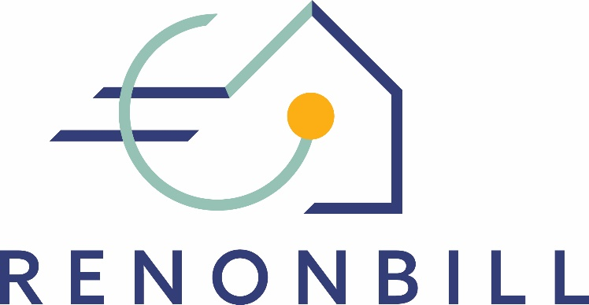

National prototyping workshops
Insights from Lithuania
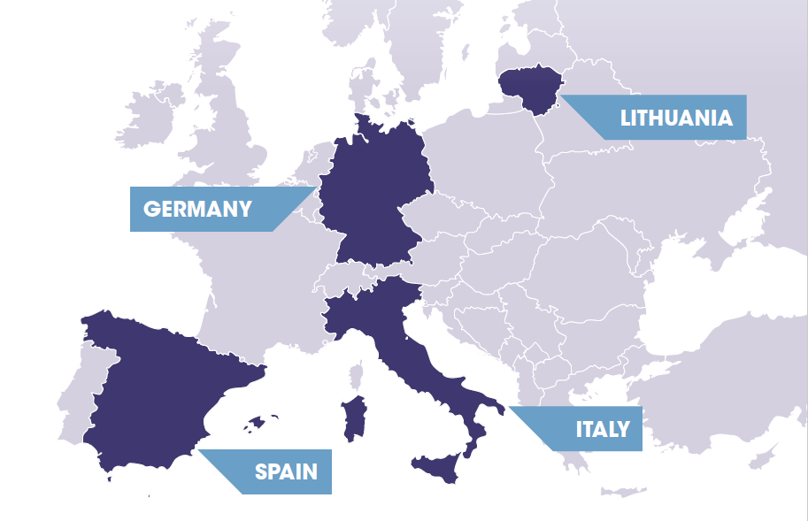
27 March 2020 | Online

This project has received funding from the European Union’s Horizon 2020 research and innovation programme under grant agreement No 847056.

Target market segments for On-bill schemes
During the workshop in Lithuania, owner-occupied multi-family houses were discussed as a suitable target market segment for OBS. This segment of the building sector can be characterised as follows:
- Owners are organised in an association;
- Owners are predominantly middle income class;
- Buildings have a low energy performance; and
- Buildings are in an urban environment.
The selected market segment seems particularly relevant for several reasons: (1) the Lithuanian government has announced to promote the renovation of multi-apartment buildings, (2) multi-apartment buildings account for almost 50% of all dwellings in Lithuania; and (3) the majority of multi-apartment buildings has not seen energy renovation so far.

ON-BILL PROTOTYPE
Financial institution
Workshop participants in Lithuania mostly envisaged an on-bill model in which a financial institution provides the up-front capital ( OBR). There was a consensus that it would be good to enable the widest possible range of financial agents to operate in this area, including for instance pension funds and crowd funding platforms, in order to expand financial capacity.
Also, participants mostly agreed that additional financial support from public sources, such as for instance the European Investment Bank’s JESSICA programme, has been well perceived in Lithuania in the past and might therefore also be a useful tool to promote on-bill schemes in the country.
Utility & master servicer
Participants pointed out that master servicers/intermediaries could play a significant role in fostering the renovation process. Ideally, the master servicers/intermediaries would be able to propose the full assortment (management, financing etc.) of services needed to renovate a building. On the other hand, licencing of financial agents is very strict and the payment collection market is full of companies that specialise in providing this service. Therefore, it may be useful to involve these companies in a potential OBS. Energy companies in partnership with a financial agent may issue bills and collect payments. Participants mentioned that energy companies are likely to be interested in offering additional services, such as for instance an OBS. End customers typically rely on their energy suppliers for a very long time and therefore trust them. When discussing about trust, participants mentioned a need of establishing a new state-owned renovation agency. This agency could serve as a knowledge hub by collecting and providing renovation-related information to various market participants.
The main message that was provided by participants: the ROB scheme should be flexible and open to changes. All participants agreed that the main goal of the new scheme introduction is to encourage and facilitate renovation. Therefore, flexibility and adaptability of an OBS was prioritised.
Supervision
Despite there are designated authorities to ensure supervision, participants pointed out that a designated authority that focuses particularly on energy renovation could be useful.
Information & Marketing
Workshop participants particularly emphasised the importance of sound information (e.g. on owners’ associations willingness to renovate) as a basis for good decisions on behalf of all parties involved in the process. Currently, many stakeholders experience a lack of information. One suggestion was to establish an information platform that would be beneficial for both the master servicer/ intermediary and the owners’ associations.
Moreover, the introduction of on-bill schemes to the Lithuanian market needs to be accompanied by public education and marketing campaigns. Ideally, this would also include information about successful on-bill cases/ best practices. This should ensure understanding of and acceptance for such a new scheme among relevant stakeholder groups.
During the workshop, the participants (guided by the moderator) developed the figure below, visualising the envisaged on-bill scheme for the Lithuanian market.
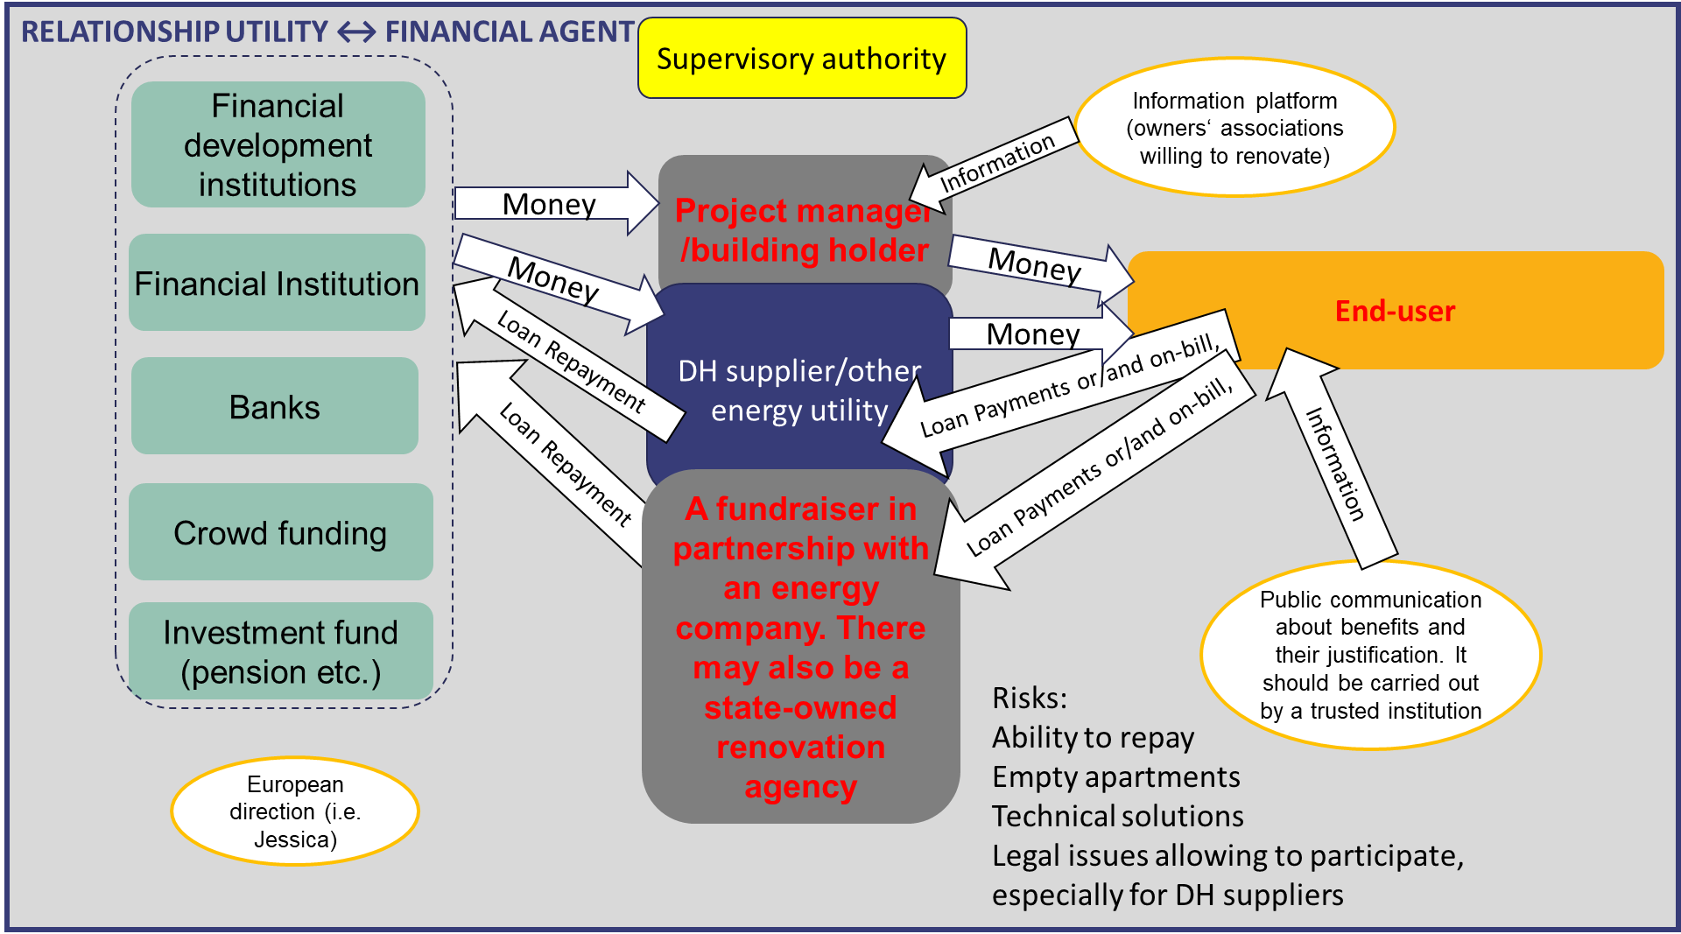
Other important issues, which were discussed during the workshop, can be summarised in opportunities and threats.
Opportunities for on-bill schemes in LT | Potential threats
- Flexibility  - Large number of potentially suitable financial agents  - Involvement of master servicers / intermediaries to coordinate the process | - Owners' ability to repay  - Empty apartments (inability to involve owner)  - Lack of appropriate technical solutions  - Legal barriers for DH suppliers to participate in an on-bill scheme

CROSS-COUNTRY COMPARISON
During all four national workshops in Spain, Italy, Lithuania, and Germany, participants discussed questions related to the relevant target market segments and to the preferences in terms of source of financing for the on-bill scheme (OBS vs. OBR). By comparison, one can see that “owner-occupied multi-family buildings” represents the most promising segment for on-bill schemes, as it is the only one that is relevant across all four countries. At the same time, participants were aware of the complications that may arise when realising an energy renovation intervention in a setting where owners may hold multiple and different interests.
In Spain and Germany, single-family houses were also considered a potential segment that may serve as a comparatively easy entry point for on-bill renovation measures. Social housing entities, however, were only mentioned in the Italian context. In any case, the selection of market segments may depend on the stakeholders who participate in the exchange. In Spain, for instance, no social agents participated in the prototyping workshop and therefore, social housing was not discussed as a primary market segment for on-bill schemes.
In terms of the overall preferred on-bill model, all participants agreed that for any large-scale intervention on-bill repayment (where investment capital is provided by a private third party) appears to be more suitable than on-bill financing. Again, this picture may change with more large-scale utilities participating in the exchange. The table below summarises these findings.
 | Target market segments |  | Preferred on-bill model
 | Owner-occupied single family-houses | Owner-occupied multi-family buildings | Social housing entities | On-bill financing (OBF) | On-bill repayment (OBR)
Lithuania
Italy
Spain
Germany

JESSICA = Joint European Support for Sustainable Investment in City Areas, https://www.eib.org/en/products/blending/jessica/index.htm.

